1. Download and Install Docker:

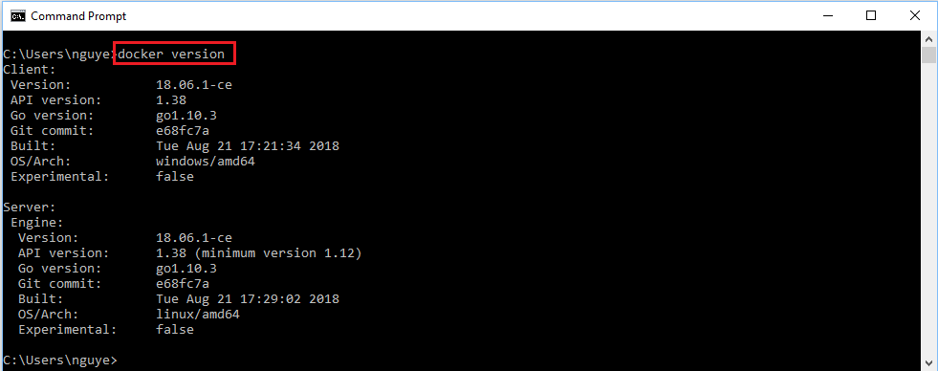

1. Add Dockerfile for an AspNetCore application:

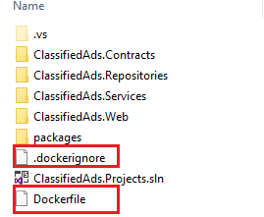

1. Compose the Dockerfile:

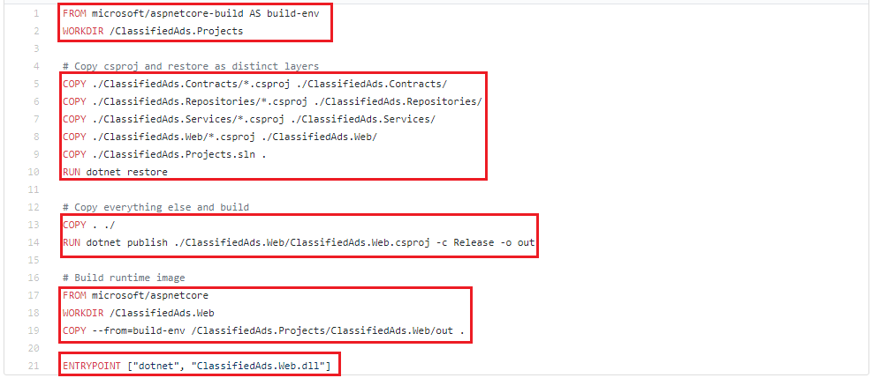

1. Run docker build command and specify the tag:

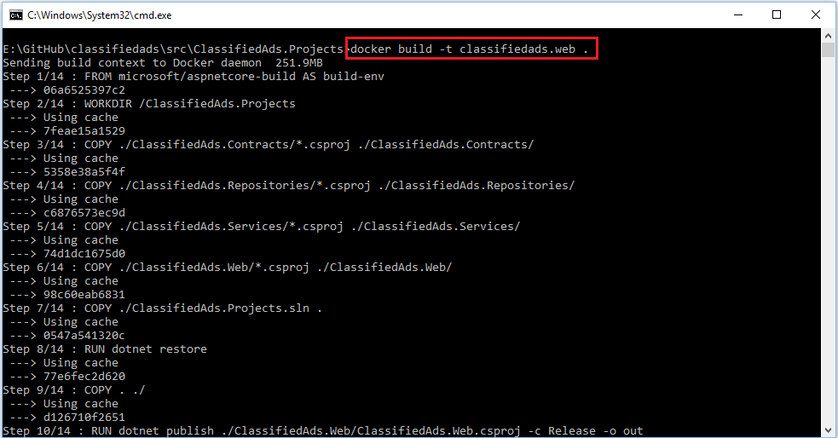

1. Verify the docker image by running a container:

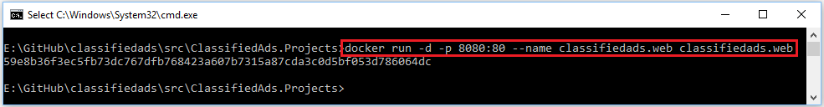

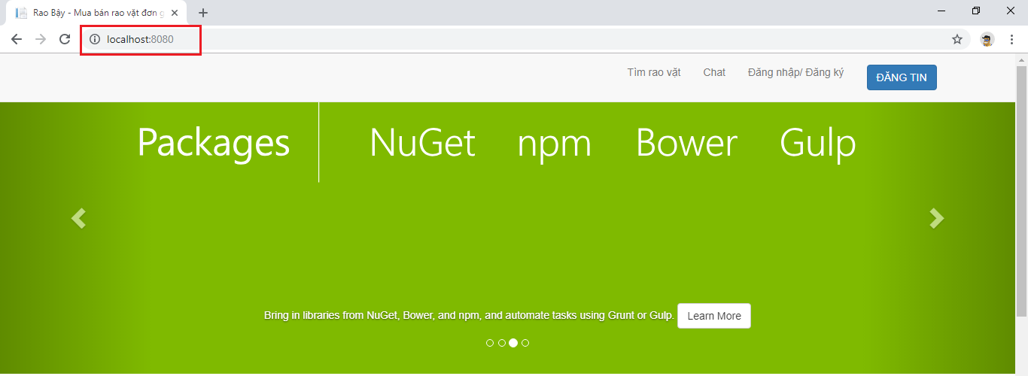

1. Create a Resource Group and a Container Registry:

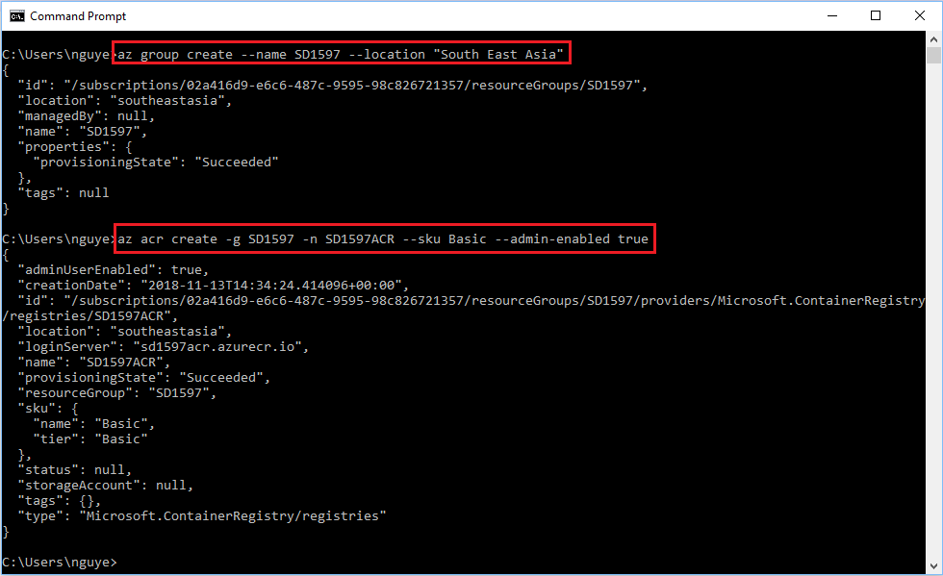

1. Login to that ACR:

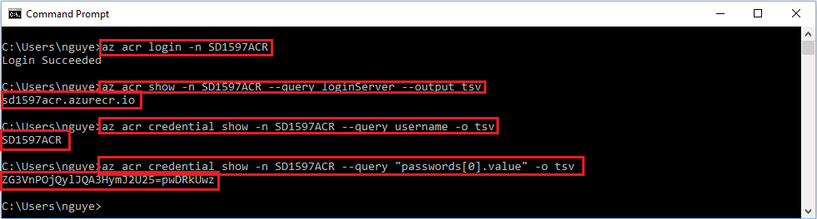

1. Push the image into ACR:

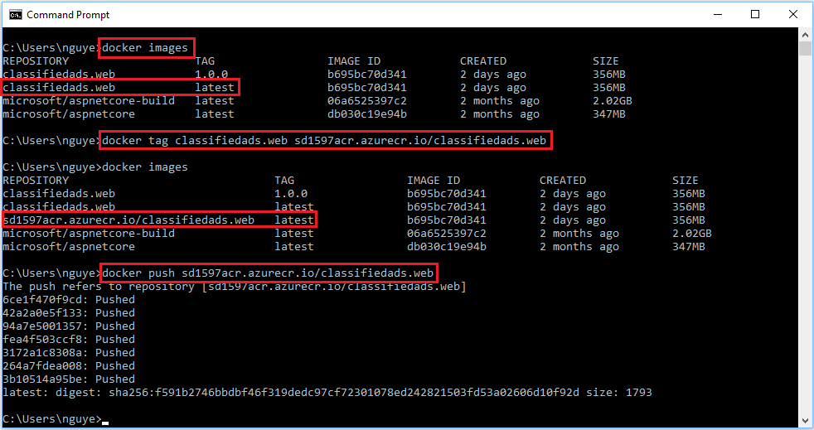

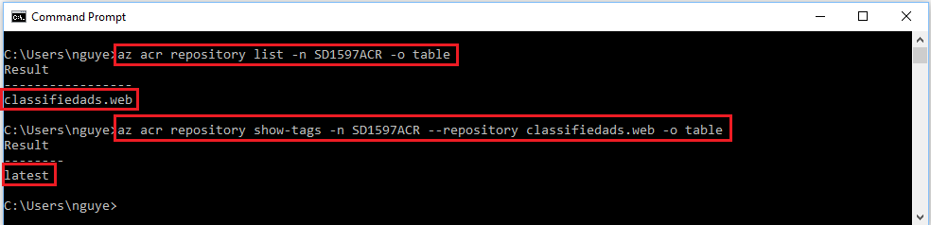

1. Deploy the image to ACI by pulling it from ACR:

* Create ACI:

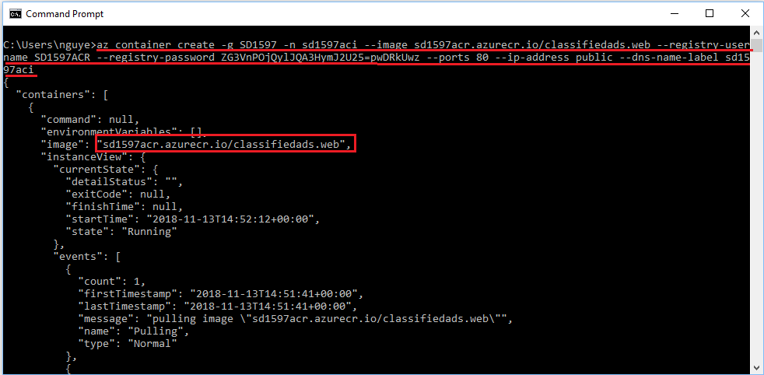

* Get the Url:

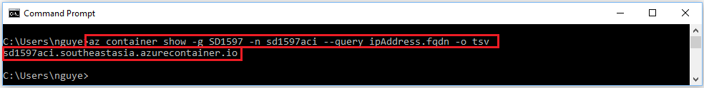

* Verify by browsing the Url above:

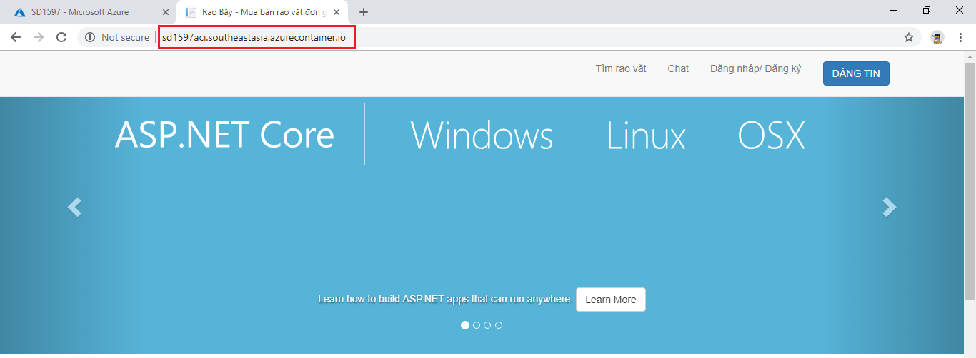

1. Deploy the image to App Service:

* Create app service plan and web app:

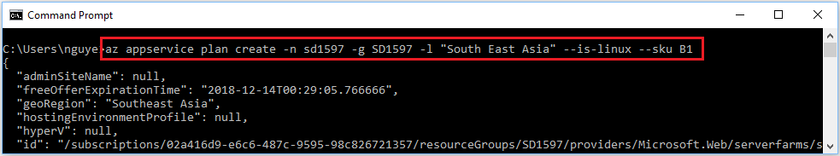

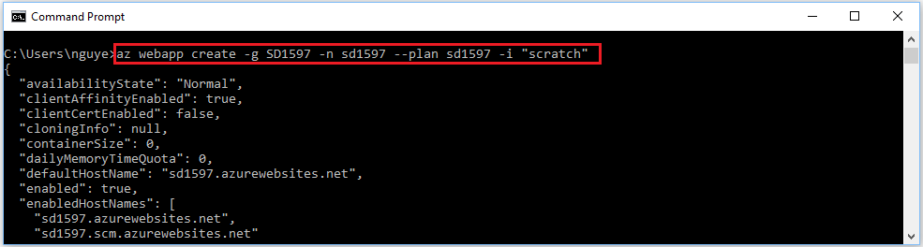

* Configure the web app to run container:

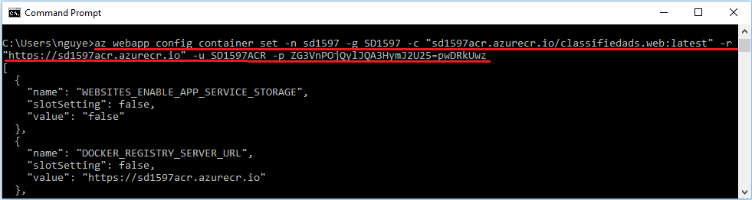

* Get the web Url:

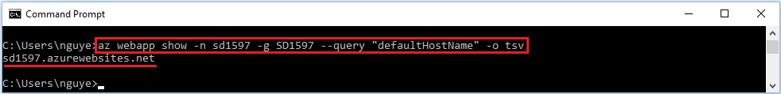

* Verify by browsing the Url above:

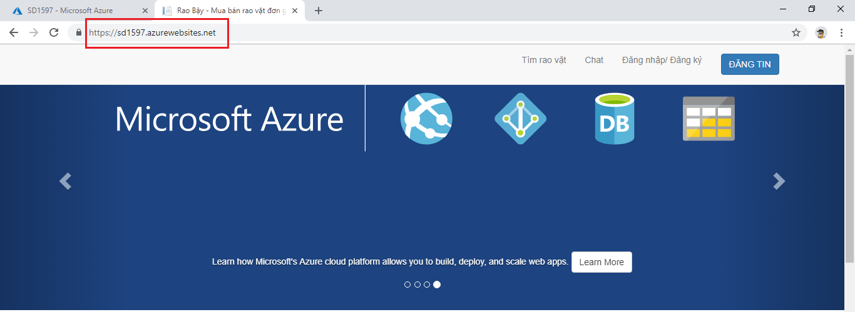

1. Automate deployment using Azure DevOps:

* Enable CD for the web app:

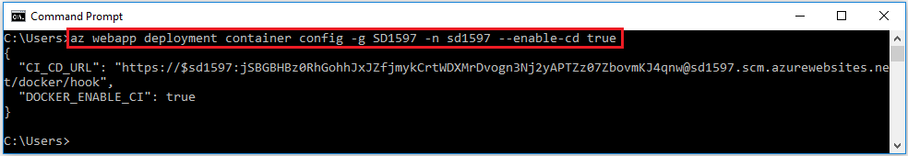

* Create a webhook:

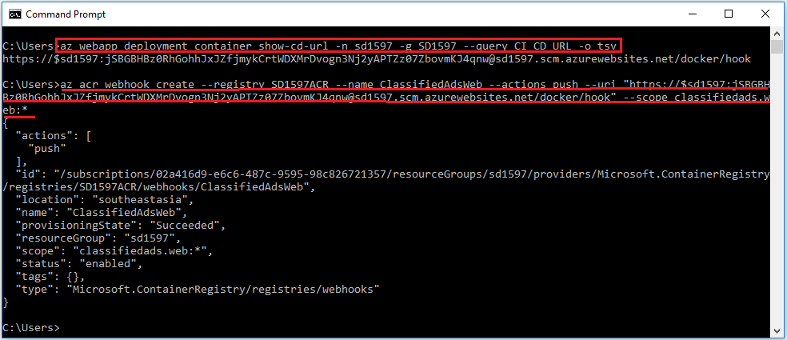

* Go to Azure DevOps portal and set up a build pipeline:

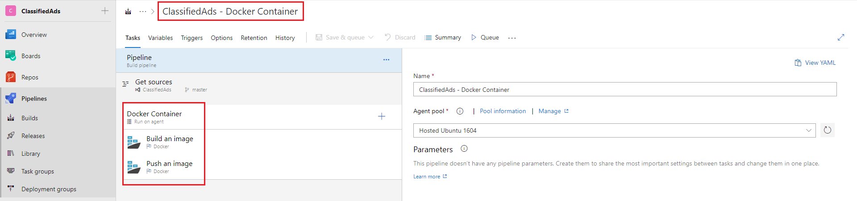

* Configure Build Image Step:

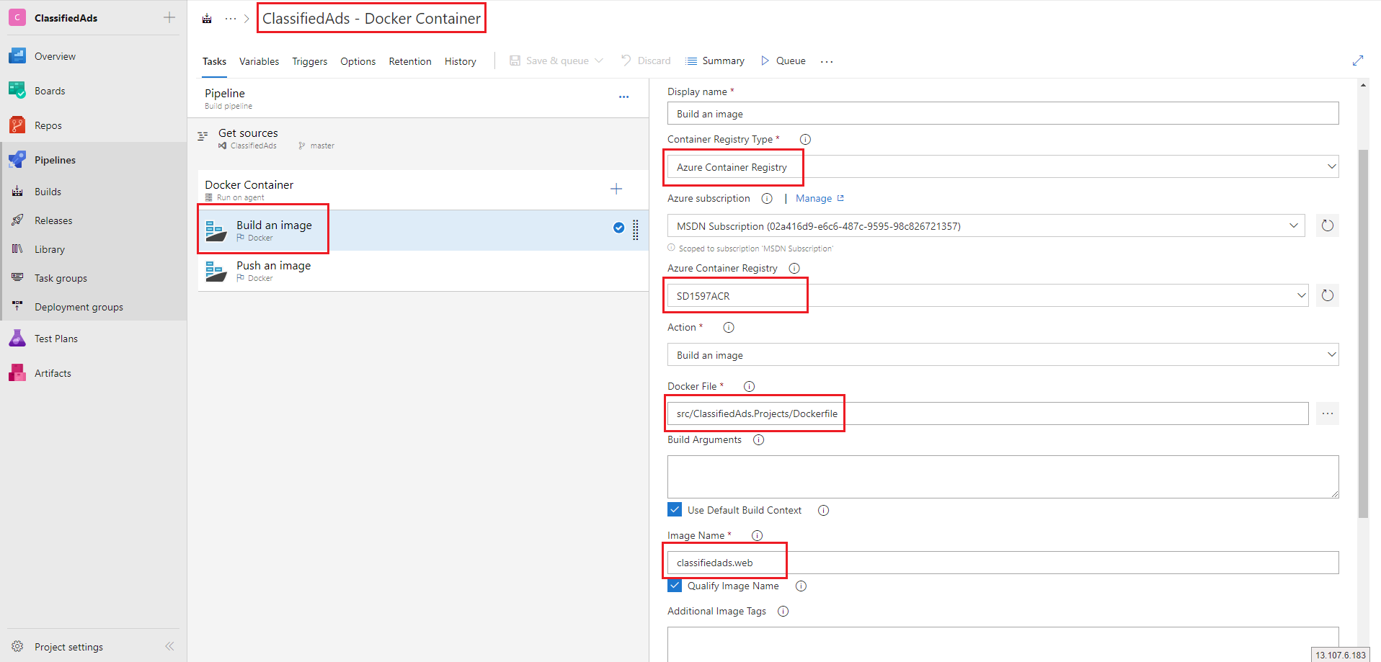

* Configure Push Image Step:

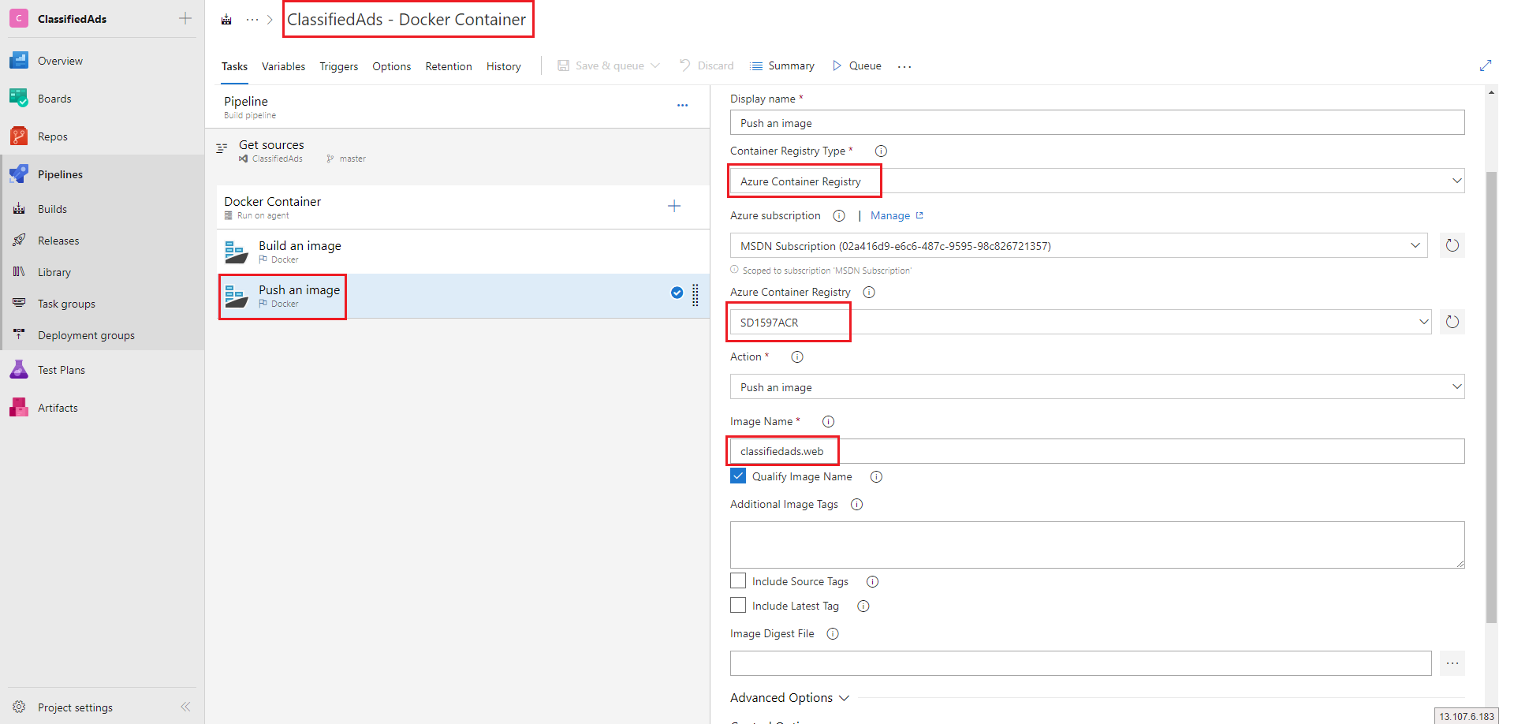

* Configure Triggers:

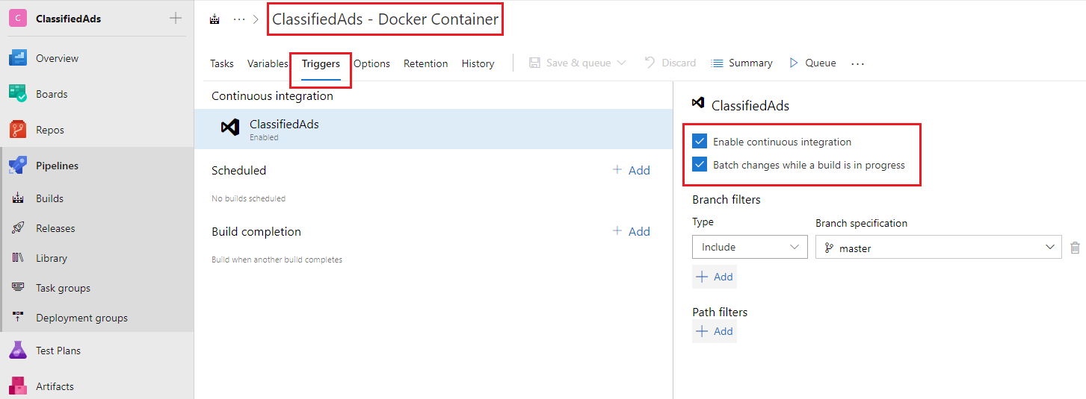

* Change something in the source code and commit:

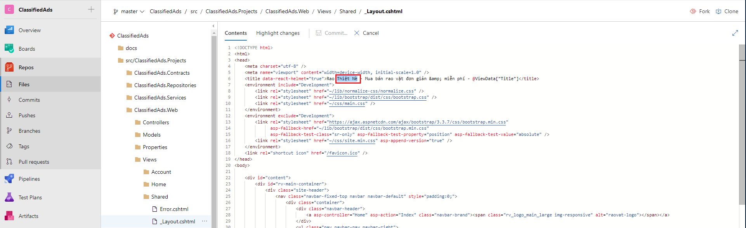

* Wait a few minutes and refresh the web page to see the change:

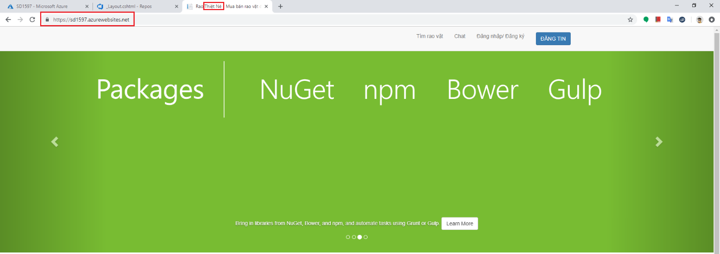

1. Clean up Resource Group:

